# PELMS_2024_20_142x108_RevC – Technical Notes

16 May 2024

## Goals

* *Recommendation 2: Develop a more portable and secure enclosure* – the PCB is being developed so that it can be placed in 142 x 110 mm enclosure,
* *Recommendation 3: Implement Power Management to Optimise Power Consumption* – the Linx Technologies RF Link components are being placed on the PCB and powered by a Mornsun DC/DC converter. The Linx Technologies RF Link components being used are: LICAL-DEC-MS001, RXM-433-LR,
* *Recommendation 4: Create a PCB for the Electrical Circuit Subsystem* – based on the original 2023 PELMS schematic for the current regulator circuit a PCB will be constructed,
* *Recommendation 5*: Increase the current rating from 10 A to 20 A – the PCB tracks and component values will be modified to work with 20 A, and
* the Linx Technologies EVAL-433-LR Receiver Board will be used for the RF link.

## Construction Notes

* Use 1.6mm board thickness.
* Use PCB Manufacturer PCBWAY with board properties of FR-4, Thickness 1.6mm, 2oz copper.
* Reduced U1 and C5 trace from 2mm to 0.5 mm.
* Put 0.75 mm trace pin 1.
* Moved C5 as close as possible to U1 (approx. 1.7 mm).
* Used R2 at 18kΩ because it is a standard value.
* Surface mount capacitor with one terminal connected to ground have a via close to the grounded terminal this is for C2, C3 and C5.
* 3-16 vias added for R6 and R7 to carry current and conduct heat.
* Top layer pour was extended 9mm.
* Screw Terminal Rated to 24A.
* L1 inductor rated only to 10.5A.
* KiCad Board Setup modifications:
  + Board Setup → Design Rules → Net Classes → Default Clearance set to 0.15 mm
  + Board Setup → Design Rules → Constraints → Minimum Clearance set to 0.15 mm

## Current Sensing Resistor Calculations

Current sensing resistor calculations are given in HV9910C Universal Brightness LED Driver Datasheet pp. 7.

RCS = 0.25 V / (1.15 x ILED)

1/RCS = 1/R8 + 1/R9

where:

* RCS is the current sensing resistor value,
* ILED is the current output from the driver into the LED (in this case the solar panel), and
* R8 and are R9 are equal value parallel resistors with a resistance equal to RCS.

Let ILED = 10A,

RCS = 0.25 V / (1.15 x ILED) = 0.25 / (1.15 x 10) = 0.021739 Ω

1/RCS = 1/R8 + 1/R9 = 2/R8

R8 = R9 = 2 x RCS = 0.043478 Ω ≈ 0.050 Ω

(Use element14 part no. 1107443 for 0.05 SMD current sensing resistor)

Let ILED = 20A,

RCS = 0.25 V / (1.15 x ILED) = 0.25 / (1.15 x 20) = 0.010869 Ω

1/RCS = 1/R8+ 1/R9 = 2/R8

R8 = R9 = 2 x RCS = 0.021739 Ω ≈ 0.025 Ω

(Use element14 part no. 3755530 for 0.025 SMD current sensing resistor)

## Mornsun DC/DC Converter EMC compliance circuit notes

* Notes are taken from **Mornsun DC/DC Converter K78UXX-500R3(L) Series** datasheet in the *Design Reference 2. EMC compliance circuit (pp 3)* section.
* The components used in the PELMS_2024_142x110_RevB schematic are:
  + Capacitors: C1, C2, C3 and C4
  + Inductor: L1
  + IC: U2
* The varistor MOV as shown below was not used.

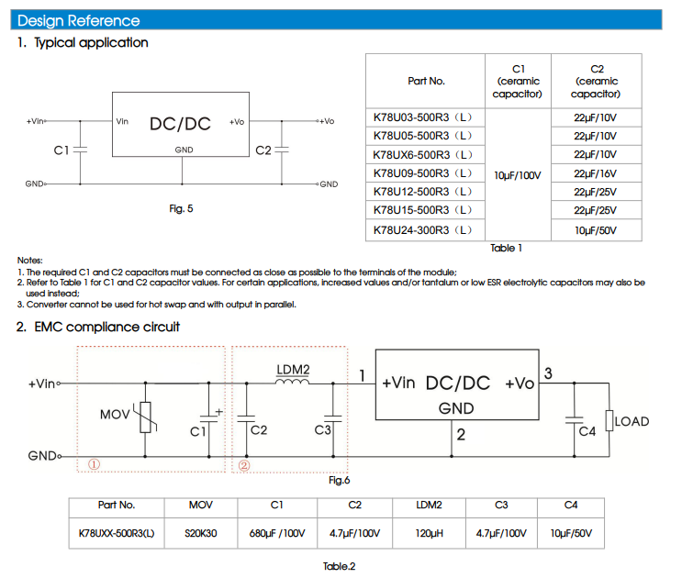

## Linx Technologies LR Receiver Evaluation Board implementation notes

* Notes are taken from **Linx Technologies LR Series Receiver Module Data Guide (revised 11/26/03)**
* Details of the Receiver Board are below:

RECEIVER EVALUATION BOARD

The receiver board is powered by two AAA batteries. The LR Series receiver exhibits a sensitivity of greater than -112dBm, so under optimum line-of-sight conditions, the transmitter / receiver link can operate over distances of up to 3,000 feet. The data recovered by the LR Series receiver is decoded by a MS Series decoder, and the data lines are updated to match the state of the data lines (or pushbuttons) on the transmitter board. To demonstrate this, one data line is used to drive a LED while another is used to activate a buzzer. This board also has a prototyping area with all of the receiver and decoder lines brought out to a header.

* The receiver board uses two modules which are configured as shown below:
  + RXM-433-LR
  + LICAL-DEC-MS

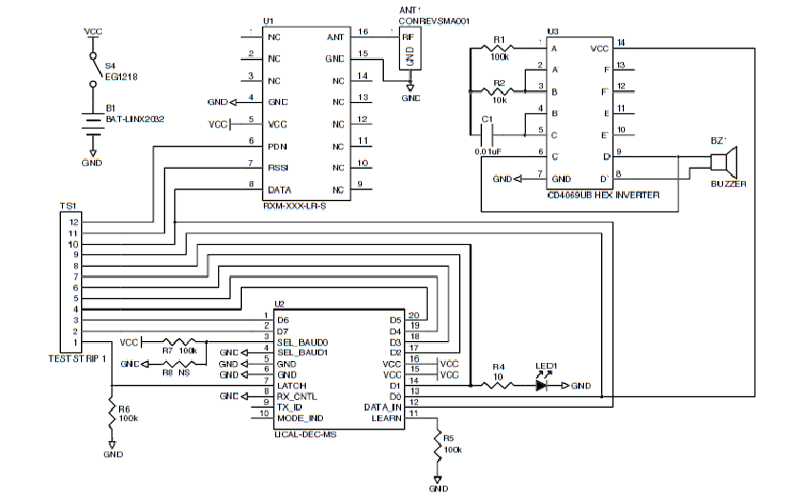

## LDO (Low-Drop-Out) Voltage Regulator LP2985-33DBVR Notes

Email: C. Jones

I don't know whether to expect any problems to be caused by the ripple coming from the K78U03-500R3 switched mode DC-DC converter. If there were problems, an option to fix it would be to install a higher voltage version of the K78Uxx-500R3 (that deals with the high battery voltage), followed by a linear regulator (that will have very low ripple and noise at its 3.3V output).

I would suggest putting in a footprint for the linear regulator after the existing switching regulator, but placing a wire link across it, to see how you go with the existing circuit, but giving you the option to fix it if there is a problem, without needing to wait for new PCBs. You can make a 3.3V linear regulator using the old adjustable LM317 but that one needs its input voltage to be at least 3V higher than its output voltage so it would need to run from the 6.5V or 9V version of the K78Uxx-500R3 switching regulator.

You could also use a LDO (low-drop-out voltage) linear regulator - these do not require much higher input voltage than their output voltage, which means that it could run from a 5V K78U05-500R3. One 3.3V LDO that I have used recently is the LP2985-33DBVR - it is quite small, but it likes to have at least 10 milliohms of resistance (I use a narrow trace on the PCB) between its output pin and the closest decoupling capacitor.

Digikey Product: <https://www.digikey.com.au/en/models/809759>

Texas Instruments, LP2985 150-mA, Low-Noise, Low-Dropout Regulator With Shutdown, Rev Jul 2023

Pp1

Pp23

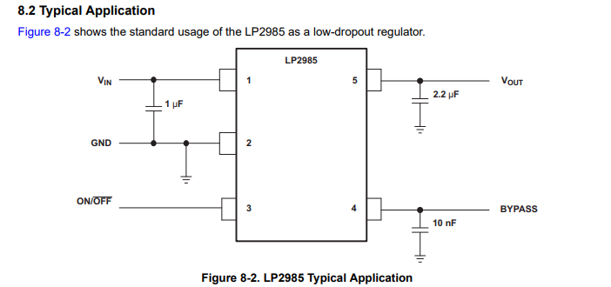

Standard values from typical application used.

## Parts List – 28 April 2024

|  |  |  |  |
| --- | --- | --- | --- |
| Part | Supplier  Part Num. | Product  Description | Notes |
| U1 – LICAL-DEC-MS001 | DigiKey  343-LICAL-DEC-MS001-TCT-ND | IC REMOTE CONTROL DECODER 20SSOP | Data decoder for RF Link.  2023 Schematic Ref: N/A |
| U2 – K78UXX-500R3 | DigiKey  2725-K78U03-500R3-ND | Non-Isolated PoL Module DC DC Converter 1 Output 3.3V 500mA 9V - 90V Input | 3.3V DC/DC Converter  2023 Schematic Ref: N/A |
| U3 – RXM-433-LR | DigiKey  RXM-433-LR-ND | LR RF Receiver ASK, OOK 433MHz -112dBm 10kbps Castellation. | 4333 MHz Receiver  2023 Schematic Ref: N/A |
| U4 – HV9910C | element14  2448503 | Led Driver, 1 Output, Buck (Step Down), 15V-450V in, 100kHz switch, NSOIC-8 | The main chip that acts as a regulator.  15V-450V, max temp of 125C  2023 Schematic Ref: HV9910C |
| U5 - LP2985-33DBVR | Digikey  296-18476-1-ND | Linear Voltage Regulator IC Positive Fixed 1 Output 150mA SOT-23-5 | LDO Voltage Regulator for DC/DC converter output.  2023 Schematic Ref: N/A |
| R1 – Resistor | element14  1469860 | VISHAY CRCW0805100KFKEA  SMD Chip Resistor, 100 kohm, ± 1%, 125 mW, 0805 [2012 Metric], Thick Film, General Purpose | Pull up resistor for pin 3 (SEL_BAUD_0) of LICAL-DEC-MS001 IC.  2023 Schematic Ref: N/A |
| R2 – Resistor | element14  1469860 | VISHAY CRCW0805100KFKEA  SMD Chip Resistor, 100 kohm, ± 1%, 125 mW, 0805 [2012 Metric], Thick Film, General Purpose | Pull down resistor for pin 7 (LATCH) of LICAL-DEC-MS001 IC.  2023 Schematic Ref: N/A |
| R3 – Resistor | element14  1469860 | VISHAY CRCW0805100KFKEA  SMD Chip Resistor, 100 kohm, ± 1%, 125 mW, 0805 [2012 Metric], Thick Film, General Purpose | Pull down resistor for pin 11 (LEARN) of LICAL-DEC-MS001 IC.  2023 Schematic Ref: N/A |
| R4 – Resistor | element14  2074387 | MULTICOMP PRO MCSR08X1802FTLSMD Chip Resistor, 18 kohm, ± 1%, 125 mW, 0805 [2012 Metric], Thick Film, Sulfur Resistant | R4 and R5 are the voltage divider to control the LD input.  Connects to potentiometer.  2023 Schematic Ref: R4 |
| R5 – Potentiometer | element14  8557527 | VISHAY 14910A0BHSX10102KA. Rotary Potentiometer, Cermet, 1 kohm, 1 Turns, Linear, 1 W, ± 10%, 149 | Current Level Control input to LD pin on U1. Helps adjust amount if current required.  U1 LD Pin Input: 0 – 250mV  VLD = R5 x VD1 / (R4 + R5)  = 1k x 5/ (18k + 1k)  = 0.263 V  2023 Schematic Ref: R3 |
| R6 – Resistor | element14  2074387 | MULTICOMP PRO MCSR08X1802FTLSMD Chip Resistor, 18 kohm, ± 1%, 125 mW, 0805 [2012 Metric], Thick Film, Sulfur Resistant | Connects to PWMD. Resistor that is used to step down the voltage to 3.3V.  Pull down resistor for PWMD pin.  2023 Schematic Ref: R2 |
| R7 – Resistor | element14  2074417 | MULTICOMP PRO MCSR08X2403FTLSMD Chip Resistor, 240 kohm, ± 1%, 125 mW, 0805 [2012 Metric], Thick Film, Sulfur Resistant | Resistor connecting to pin 8 of U1 (RT) and is the current sensing resistor ROSC which determines Oscillator Time Period TOSC.  TOSC = ROSC / 25  = 240 kΩ /25  = 9.6 ms  2023 Schematic Ref: R1 |
| R8 - Resistor | element14  4070830 | EATON BUSSMANN MFL0805R0250FS  SMD Current Sense Resistor, 0.025 ohm, MFL Series, 0805 [2012 Metric], 500 mW, ± 1%, Metal Film | Current Sensing Resistor RCS where:  RCS = 1 / (1/R8 + 1/R9)  = 0.25V / (1.15 x ILED)  R8 and R9 are equal.  2023 Schematic Ref: R6 |
| R9 - Resistor | element14  4070830 | EATON BUSSMANN MFL0805R0250FS  SMD Current Sense Resistor, 0.025 ohm, MFL Series, 0805 [2012 Metric], 500 mW, ± 1%, Metal Film | Current Sensing Resistor RCS where:  RCS = 1 / (1/R8 + 1/R9)  = 0.25V / (1.15 x ILED)  R8 and R9 are equal.  2023 Schematic Ref: R7 |
| R10 - Resistor | element14  2518222 | VISHAY WSLP0805R0100FEA18  SMD Chip Resistor, 0.01 ohm, ± 1%, 1 W, 0805 [2012 Metric], Metal Strip, General Purpose | Provides a 10 mΩ trace resistance for LDO LP2985 between the VOUT pin and the output capacitor.  2023 Schematic Ref: N/A |
| J1 – Anderson Powerpole Connectors | element14  2949132 | PLUG/RCPT HOUSING, 2POS, PC, RED/BLK | Anderson PP30 Powerpole Connectors  2023 Schematic Ref: N/A |
| J2 – 4-Way Pin Header | element14  589068 | Pin Header, Wire-to-Board, 3.96 mm, 1 Rows, 4 Contacts, Through Hole Straight, MTA-156 | Connection to Switch.  5V / 18 k = 0.277 mA  2023 Schematic Ref: N/A |
| J3 – 4-Way Socket | element14  1098736 | IDC Connector, 24 AWG, IDC Receptacle, Female, 3.96 mm, 1 Row, 4 Contacts, Cable Mount | Connection to Switch.  2023 Schematic Ref: N/A |
| J4 - Screw Terminal | element14  3041165 | PHOENIX CONTACT 1711725  Wire-To-Board Terminal Block, 5.08 mm, 2 Ways, 24 AWG, 12 AWG, 1.5 mm², Screw | Connection to Battery Input Voltage Source.  Rated to 24A and suitable for 12AWG.  2023 Schematic Ref: N/A |
| J5 – 3-Way Pin Header | element14  589056 | Pin Header, Vertical, Wire-to-Board, 3.96 mm, 1 Rows, 3 Contacts, Through Hole Straight, MTA-156 | Connection to Potentiometer R5.  2023 Schematic Ref: N/A |
| J6 – 3-Way Socket Connector | element14  1098735 | IDC Connector, 24 AWG, IDC Receptacle, Female, 3.96 mm, 1 Row, 3 Contacts, Cable Mount | Connection to Potentiometer R5.  2023 Schematic Ref: N/A |
| J8 - Screw Terminal | element14  3041165 | PHOENIX CONTACT 1711725  Wire-To-Board Terminal Block, 5.08 mm, 2 Ways, 24 AWG, 12 AWG, 1.5 mm², Screw | Connection to Ammeter.  Rated to 24A and suitable for 12AWG.  2023 Schematic Ref: N/A |
| J9 - Screw Terminal | element14  3041165 | PHOENIX CONTACT 1711725  Wire-To-Board Terminal Block, 5.08 mm, 2 Ways, 24 AWG, 12 AWG, 1.5 mm², Screw | Connection to Solar Panel Output Current.  Rated to 24A and suitable for 12AWG.  2023 Schematic Ref: N/A |
| C1 – Capacitor | DigiKey  EKY-101ELL681ML40S | CAP ALUM 680UF 20% 100V RADIAL | EMC compliance circuit input capacitor. |
| C2 – Capacitor | DigiKey  445-173304-1-ND | CAP CER 4.7UF 100V X7S RADIAL | EMC compliance circuit input capacitor. |
| C3 – Capacitor | DigiKey  445-173304-1-ND | CAP CER 4.7UF 100V X7S RADIAL | EMC compliance circuit input capacitor. |
| C4 – Capacitor | DigiKey  445-173153-1-ND | CAP CER 10UF 50V X5R RADIAL | EMC compliance circuit output capacitor. |
| C5 – Capacitor | element14  3416400 | TDK CGA4J3X7S2A105M125AB  SMD Multilayer Ceramic Capacitor, 1 µF, 100 V, 0805 [2012 Metric], ± 20%, X7S | Connects to HV9910CLG VDD pin.  2023 Schematic Ref: C2 |
| C6 – Capacitor | element14  3369008 | YAGEO AS0805KKX7R0BB104  SMD Multilayer Ceramic Capacitor, 0.1 µF, 100 V, 0805 [2012 Metric], ± 10%, X7R, AS Series | Connects to HV9910CLG LD pin.  2023 Schematic Ref: C3 |
| C7 – Capacitor | element14  3369008 | YAGEO AS0805KKX7R0BB104  SMD Multilayer Ceramic Capacitor, 0.1 µF, 100 V, 0805 [2012 Metric], ± 10%, X7R, AS Series | Connects to HV9910CLG VIN pin.  2023 Schematic Ref: C5 |
| C8 – Capacitor | element14  2346421 | RUBYCON 63ZLH1800MEFC18X35.5  Electrolytic Capacitor, Miniature, 1800 µF, 63 V, ± 20%, Radial Leaded, 10000 hours @ 105°C, Polar | Input Capacitor.  2023 Schematic Ref: N/A |
| C9 – Capacitor | element14  2346421 | RUBYCON 63ZLH1800MEFC18X35.5  Electrolytic Capacitor, Miniature, 1800 µF, 63 V, ± 20%, Radial Leaded, 10000 hours @ 105°C, Polar | Input Capacitor.  2023 Schematic Ref: N/A |
| C10 – Capacitor | element14  2346421 | RUBYCON 63ZLH1800MEFC18X35.5  Electrolytic Capacitor, Miniature, 1800 µF, 63 V, ± 20%, Radial Leaded, 10000 hours @ 105°C, Polar | Input Capacitor.  2023 Schematic Ref: N/A |
| C11 – Capacitor | element14  2079307 | PANASONIC EEUFR1J391B Electrolytic Capacitor, 390 µF, 63 V, ± 20%, Radial Leaded, 10000 hours @ 105°C, Polar | Output Capacitor.  2023 Schematic Ref: C6 |
| C12 – Capacitor | element14  3416400 | TDK CGA4J3X7S2A105M125AB  SMD Multilayer Ceramic Capacitor, 1 µF, 100 V, 0805 [2012 Metric], ± 20%, X7S | LDO Input Capacitor.  2023 Schematic Ref: N/A |
| C13 – Capacitor | element14  2942352 | KEMET C0805C103K5RALTU  SMD Multilayer Ceramic Capacitor, 0.01 µF, 50 V, 0805 [2012 Metric], ± 10%, X7R, C Series KEMET | LDO Bypass Capacitor.  2023 Schematic Ref: N/A |
| C14 – Capacitor | element14  3881065 | WALSIN 1206B225K101CP  SMD Multilayer Ceramic Capacitor, 2.2 µF, 100 V, 1206 [3216 Metric], ± 10%, X7R | LDO Output Capacitor.  2023 Schematic Ref: N/A |
| C15 – Capacitor | element14  3416400 | TDK CGA4J3X7S2A105M125AB  SMD Multilayer Ceramic Capacitor, 1 µF, 100 V, 0805 [2012 Metric], ± 20%, X7S | LICAL-DEC-MS001 VCC Input Capacitor.  2023 Schematic Ref: N/A |
| C16 – Capacitor | element14  3416400 | TDK CGA4J3X7S2A105M125AB  SMD Multilayer Ceramic Capacitor, 1 µF, 100 V, 0805 [2012 Metric], ± 20%, X7S | RXM-433-LR VCC Input Capacitor.  2023 Schematic Ref: N/A |
| Q1 – MOSFET | element14  2480793 | Power MOSFET, N Channel, 100 V, 45 A, 0.0075 ohm, TO-220FP, Through Hole | Used to connect the chip to the circuit and panel. 100V 45A rating.  2023 Schematic Ref: MOSFET |
| D1 – Diode | element14  2675797 | MULTICOMP PRO MBR20100CTSchottky Rectifier, 100 V, 20 A, Dual Common Cathode, TO-220AB, 3 Pins, 950 mV | Schottky Styled Rectifier 100V, 20A  2023 Schematic Ref: D2 |
| L1 - Inductor | DigiKey  RLB0914-121KL-ND | FIXED IND 120UH 1.05A 320MOHM TH | EMC compliance circuit series input inductor. |
| L2 - Inductor | element14  1864220 | MULTICOMP PRO MCAP113014014K-150MUToroidal Inductor, MCAP, 15 µH, 20 A, 0.007 ohm, ± 20% | Toroidal styled inductors 15 uH.  2023 Schematic Ref: L1 |

## PCB Views – FRONT & BACK – 142 mm x 108 mm

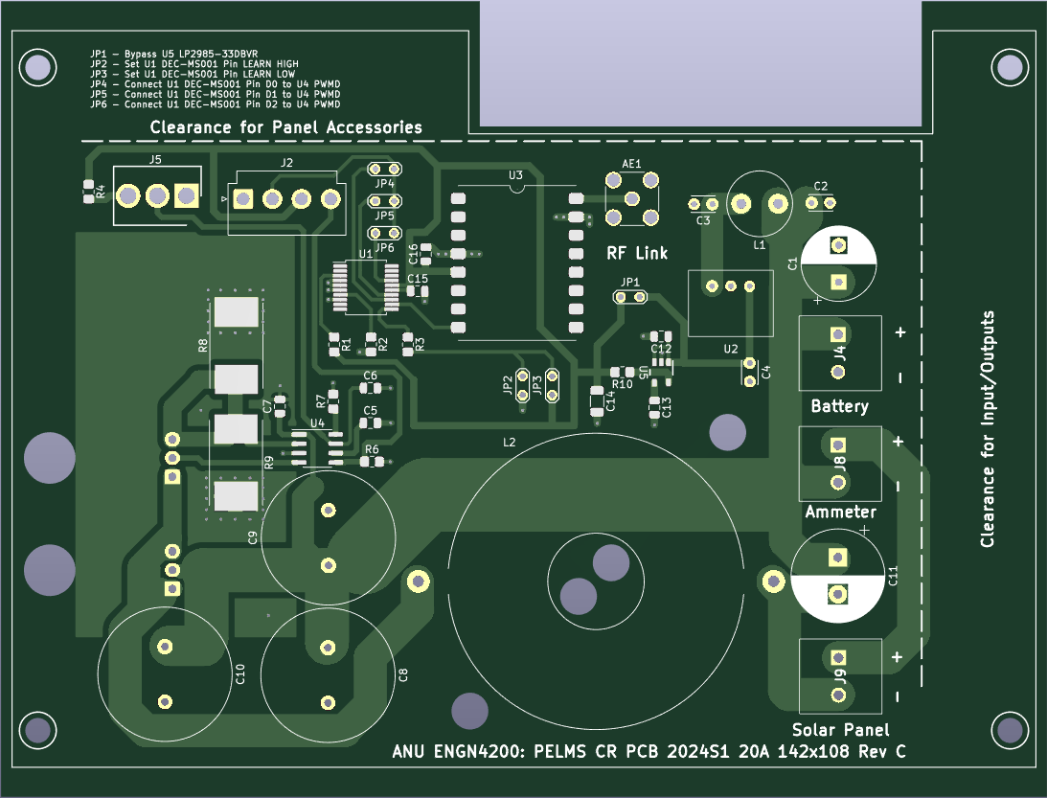

**Figure 1: PCB Front**

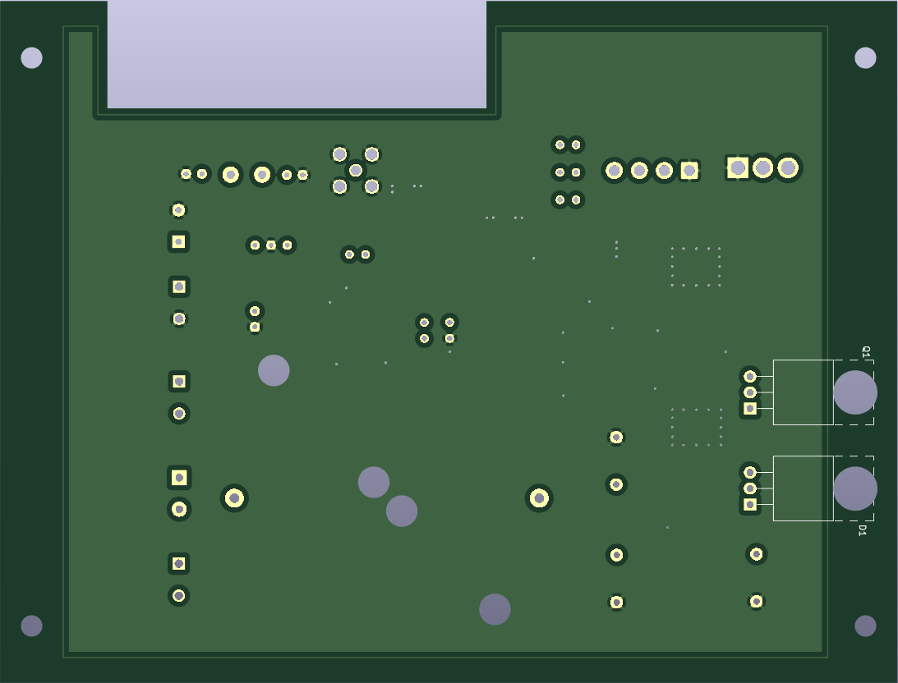

**Figure 2: PCB Back**